ISTITUTO COMPRENSIVO “U. FOSCOLO” DI VESCOVATO
Via Corridoni, 1 26039 VESCOVATO
Scuola Primaria - Plesso di ____________________
Anno scolastico 2014/2015

LINGUA INGLESE

Verifica di fine secondo quadrimestre

Writing Test

CLASSE 5^

Name: Date:
Surname:

1 Write the questions
1 you a buy can Where hat? ____________________________________
2 some have I Can comics? ____________________________________
3 much that How is? ____________________________________
4 What’s doing he? ____________________________________
5 her What’s job? ____________________________________
6 cave there a Is? _____________________________________
/ 6
2 Choose and write.
brothers - subjects - from - dad - go - three - are - nurse - a

Hi!
I’m Ann. I’m (1) __________ the UK and I live in London. There’s a river in London and there
(2) _____________ famous buildings.
I (3) ______________ to Grove Primary School. My favourite (4) ____________ are History and
Maths.
I’ve got (5) ____________ sisters and two (6) _______________ . My mum is a (7) __________
and my (8) _________________ is (9) __________ fireman.
Write soon! Bye!
/9

3 Write a letter about Ann (3° persona)
/8

4 Write about the pictures.
1 He’s _________________
2 She’s _________________
3 _______________________
4 _______________________
5 ______________________

/5

1 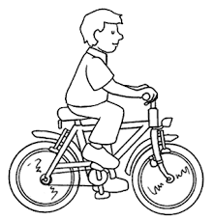 2 3 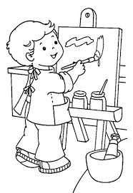 4 5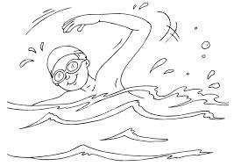

Tot / 28

CRITERI DI VALUTAZIONE
28/28 voto 10
27/28 voto 9
26/28 voto 9
25/28 voto 8
24/28 voto 8
23/28 voto 8
22/28 voto 8
21/28 voto 7
20/28 voto 7
19/28 voto 7
18/28 voto 6
17/28 voto 6
16/28 voto 6
15/28 voto 6
14/28 voto 5

